CHAPTER 5: OPTION PRICING MODELS: THE BLACK-SCHOLES-MERTON MODEL

END-OF-CHAPTER QUESTIONS AND PROBLEMS

1. (Characteristics of the Black-Scholes-Merton Formula) The formula has two terms:

S₀N(d₁),

is the present value of the expected value of the stock price, conditional on the option expiring in-the-money discounted at the risk-free rate. The second term,

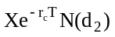

is the present value of the expected payout of the exercise price at the expiration. N(d₂) is the probability of exercise. All of this is based on the condition of risk neutrality, meaning that the probability distribution is based on a risk-free expected return on the stock.

2. (Variables in the BSM Model) a. The delta is the change in the call price for a given change in the stock price. Strictly speaking the delta applies only when the stock price changes by a very small amount. The delta also gives the hedge ratio, which tells how many shares of stock must be held (or sold short) to hedge a given short (or long) position in calls. The delta is between zero and one and, as expiration approaches, converges to one if the option is in-the-money and zero if the option is out-of-the-money.

b. Gamma is the change in delta for a given (again very small) change in the stock price. The gamma measures the risk involved in not adjusting the hedge ratio to equal the delta. The gamma will be large when the option is at-the-money and nearly zero when the option is deep in- or out-of-the-money.

c. Rho measures the change in the option price when the risk-free rate changes. The relationship is nearly linear and is fairly weak. In other words, the call price is not very sensitive to the risk-free rate.

d. Vega (also called kappa and lambda) measures the change in the option price for a change in the volatility. The relationship is nearly linear when the option is at-the-money. The option price is very sensitive to the volatility.

e. Theta is the relationship between the option price and the time to expiration. For European calls, the theta is negative meaning that the option price will fall as expiration approaches.

- (Implied Volatility) If you accept the "theoretically correct" standard deviation as the true volatility, then the market price of the option is implying a higher volatility of the stock than is reasonable. That is, the implied volatility obtained by setting the Black-Scholes-Merton price equal to the market price is higher than it should be. This means that the market price is too high. You would consider selling the overpriced option, perhaps in conjunction with the purchase of the stock.

4. (Implied Volatility) a. Implied volatilities can indeed vary for options on the same stock with the same exercise price and different expirations. The volatility is supposed to be the volatility of the stock over the life of the option so it can indeed vary with a different time to expiration. The difference in volatilities is called the term structure of implied volatility.

b. In theory implied volatilities should not vary for options on the same stock with the same expiration and different exercise prices. The volatility is referring to the volatility of the stock over a given period of time. There cannot be but one such volatility. In practice, however, there are multiple volatilities, which is often referred to as the volatility smile or skew.

c. Often option prices are quoted using the implied volatility. A given option price could be quoted by stating its implied volatility, while another option on the same stock could be quoted by stating a different implied volatility. It is assumed that the actual option price is then found by plugging into a model such as Black-Scholes-Merton. The purpose of quoting option prices this way is because it is much easier to see which are the more expensive options.

5. (Stock Price) The primary reason is the inability to trade at no cost over a very small time interval. Delta hedging assumes only very small stock price moves. If the stock price makes a sufficiently large move, the delta changes too quickly. To manage this risk, one must hedge the gamma. These types of large moves are more prone to occur over longer time intervals. Thus, if one cannot trade frequently, large stock price moves can occur between trades, and this will make it harder to maintain the delta neutral position. In addition transaction costs make it difficult to delta hedge perfectly. Transaction costs discourage frequent trading and make it impossible to actually earn the risk-free rate.

6. (A Nobel Formula) The European lower bound is

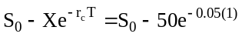

S₀ C Lower Bound C ≥ Lower Bound ?
5 0.00 0.00 yes
10 0.00 0.00 yes
15 0.00 0.00 yes
20 0.02 0.00 yes
25 0.15 0.00 yes
30 0.57 0.00 yes
35 1.48 0.00 yes
40 3.02 0.00 yes
45 5.23 0.00 yes
50 8.06 2.44 yes
55 11.44 7.44 yes
60 15.25 12.44 yes
65 19.40 17.44 yes
70 23.80 22.44 yes
75 28.38 27.44 yes
80 33.09 32.44 yes
85 37.88 37.44 yes
90 42.74 42.44 yes
95 47.65 47.44 yes
100 52.58 52.44 yes

7. (A Nobel Formula) a. S₀ = 165.13, X = 165, r_{c} = 0.0571, σ = 0.21, and T = 0.2795 (102 days from 7/6 to 10/16)

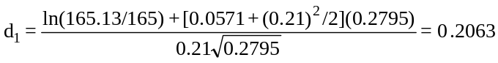
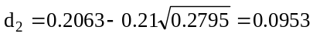

N(0.21) = 0.5832 N(0.10) = 0.5398

C = 165.13(0.5832) – 165e^{–0.0571(0.2795)}(0.5398) = 8.647

Using BlackScholesMertonBinomial10e.xlsm, you should obtain approximately 8.7020.

b. The actual price is 8.13. The call appears to be underpriced. We should buy 1,000 calls and sell short 1,000(0.583) = 583 shares and revise the hedge continuously so that the proper ratio of calls to shares is maintained.

c. For each dollar change in the stock price, the option price changes by approximately the value of N(d₁), its delta, of 0.583. So if 583 shares that were sold short decrease in value by one dollar, the gain is $583, but the 1,000 calls will decrease in value by $0.583 each. Since we are long the calls, we lose $583 on the calls. Thus, the loss on the long calls should be offset by the gain on the short stock.

8. (A Nobel Formula) a. We have

P = 165e^{-.0571(.2795)}(1 – 0.5398) – 165.13(1 – 0.5832) = 5.905

Using BlackScholesMertonBinomial10e.xlsm, you should obtain approximately 5.9600.

b. The put appears to be overpriced at 6.75. You should sell 1,000 puts and sell short
–(0.5832 – 1)1,000 = 417 shares. We should note, however, that in reality the put might not be overpriced since the Black-Scholes-Merton model does not account for the privilege of early exercise.

c. We would gain $417 by being short 417 shares. We would lose $417 on the puts because we are short 1,000 puts that increase in value by 0.417 each. Thus, the loss on the short puts is exactly offset by the gain on the short stock.

- (BSM Model When the Stock Pays Dividends) The time to the ex-dividend date is 66 days, so t = 66/365 = 0.1808. We adjust the stock price to

165.13 – 1.10e^{-0.0571(0.1808)} = 164.041

Inserting into the Black-Scholes-Merton model, we have

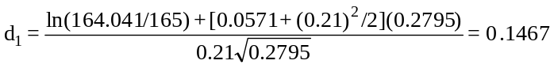

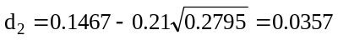

N(0.15) = 0.5596

N(0.04) = 0.5160

C = 164.041(0.5596) – 165e^{–0.0571(0.2795)}(0.5160) = 8.005

Using BlackScholesMertonBinomial10e.xlsm you should obtain 8.0812.

10. (BSM Model When the Stock Pays Dividends) Adjust the stock price to

165.13e^{-0.027(0.2795)} = 163.889

Inserting into the Black-Scholes-Merton model, we have
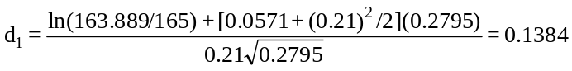

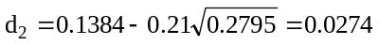

N(0.14) = 0.5557

N(0.03) = 0.5120

C = 163.889(0.5557) – 165e^{–0.0571(.2795)}(0.5120) = 7.931=
Using BlackScholesMertonBinomial10e.xlsm, you should obtain 7.9966.

11. (BSM Model and Some Insights into American Call Options) On July 7 there will be 10 days remaining so the time to expiration will be 10/365 = 0.0274. As soon as the stock goes ex-dividend, its price will fall to 163.13. Then the option price will be

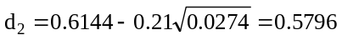

N(0.61) = 0.7291

N(0.58) = 0.7190

C = 163.13(0.7291) – 160e^{–0.0503(0.0274)}(0.7190) = 4.06
Exercise just before the stock goes ex-dividend would net 165.13 – 160 = 5.13 so you should exercise.

12. (Historical Volatility) The solution is

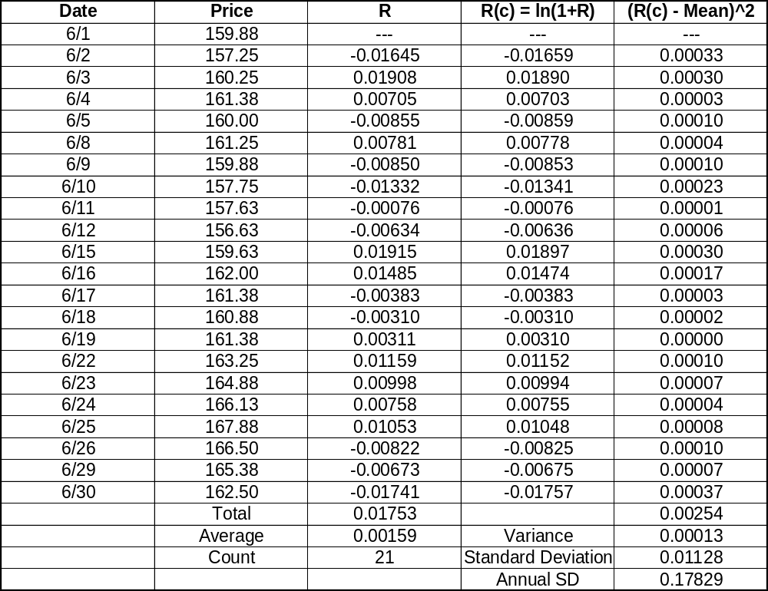

13. (Estimating the Volatility) S₀ = 165.13, X = 165, r_{c} = 0.0535, T = 0.126, C = 5.25

At σ = 0.20, the Black-Scholes-Merton price is approximately 5.30. At σ = 0.19, the Black-Scholes-Merton price is approximately 5.07. The implied volatility is, therefore, between 19 and 20 percent. This is slightly higher than the historical volatility obtained in Problem 17, meaning that the volatility has recently increased.

14. (Estimating the Volatility)

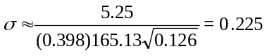

It is a little high but provides a good starting point. Of course, the call is slightly in the money anyway so the estimate will tend to be a little off.

15. (A Nobel Formula) S₀ = $0.4728, X = $0.46, r_{c} = 0.071, ρ_{c} = 0.036, σ = 0.145, T = 35/365 = 0.0959 (based on 35 days between December 9 and January 13)
First adjust the spot exchange rate: S₀′ = 0.4728e^{-0.036(0.0959)} = 0.4712

Then calculate d₁ and d₂,

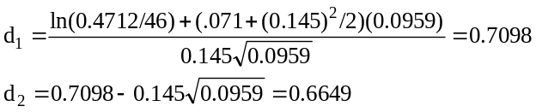

Look up the normal probabilities:

N(0.71) = 0.7611

N(0.66) = 0.7454

Then calculate the option price:

c = 0.4712(0.7611) – 0.46e^{-0.071(0.0959)}(0.7454) = 0.0181

The call should be selling for $0.0181 so it is underpriced at $0.0163.

16. (Managing the Risk of Options) Plugging into the Black-Scholes-Merton model S₀ = 100, X = 100,
r_{c} = 0.045, T = 1, σ = .40, we obtain C = 17.80 and a delta of 0.6227. Sell 10,000 calls and buy 6,227 shares. The value of the portfolio is now

V = 6,227(100) – 10,000(17.80) = 444,700.

- Now at the end of Day 1, S₁ = 99, T = 364/365 = 0.9973. Plugging into the Black-Scholes-Merton model, we obtain C = 17.1559. Our portfolio is now worth

V₁ = 6,227(99) – 10,000(17.1559) = 444,914.

The new delta from the Black-Scholes-Merton model would be 0.6129. So we need 6,129 shares. We sell 6,227 – 6,129 = 98, raising 98(99) = 9,702, which we invest in risk-free bonds.

Now at the end of Day 2, S₂ = 102, T = 363/365 = 0.9945. Plugging into the Black-Scholes-Merton model we obtain 19.0108. Our portfolio is now worth

V₂ = 6,129(102) – 10,000(19.0108) + 9,702e^{0.045(1/365)} = 444,753.

The amount we should have had is the initial amount invested plus two days interest:

444,700e^{0.045(2/365)} = 444,810.

The target was not achieved because a delta hedge works well only for very small changes in the stock price. The discrepancy between the amount we obtained and the target is due to the gamma risk, which reflects large stock price moves.

- Going back to Day 0, on the original option, we would obtain a gamma of 0.0095. Now we add a new option. Its Black-Scholes-Merton value is 15.6929, its delta is 0.5756 and its gamma is 0.0098. Remember that we have 10,000 of the first option. The number of the second is

10,000(0.0095/0.0098) = 9,694.

The number of shares of stock we need is

10,000(0.6227 – (0.0095/0.0098).5756) = 647.

So now our portfolio value is

V₁ = 647(100) – 10,000(17.80) + 9,694(15.6929) = 38,827.

Now on Day 1, the stock is at 99. From the Black-Scholes-Merton formula, the first call price is 17.1559, its delta is 0.6129 and its gamma is 0.0097. The second call is at 15.0958, its delta is 0.5654 and its gamma is 0.0100. The value of the portfolio is

V₂ = 647(99) – 10,000(17.1559) + 9,694(15.0958) = 38,833.

Now we revise the number of the second call to

10,000(0.0097/0.0100) = 9,700.

We revise the number of shares to

10,000(0.6129 – (0.0097/.0100).5654) = 645.

So we need to buy 9,700 – 9,694 = 6 more of the second call and sell 647 – 645 = 2 shares. This will generate

2(99) – 6(15.0958) = 107, which we invest in bonds.

Now on Day 2, the stock is at 102. The Black-Scholes-Merton value is 19.0108 for the first call and 16.8092 for the second. The portfolio is now worth

V₂ = 644(102) – 10,000(19.0108) + 9,700(16.8092) + 107e^{0.045(1/365)} = 38,838.

The amount we should have is 38,827 plus two days interest:

38,827e^{0.045(2/365)} = 38,837.

We see that we have nearly a perfect hedge. The target was achieved because gamma hedging is able to eliminate risk caused by the larger price movement better than delta hedging alone.

17. (A Nobel Formula) Using either software package and the inputs S₀ = 82, X = 80, r = 0.04 (continous),
σ = 0.3, and T = 1, the current call price is 15.32. If the option pays off 150% of the value of an ordinary option on this stock, then it is equivalent to an option on a stock currently priced at 82(1.50) = 123 with an exercise price of 80(1.5) = 120. That is, the ordinary option pays S_{T} – X or 0. This new option pays
1.50(S_{T} – X) or 1.5(0) = 0. This is just like multiplying the stock price and exercise price by 1.5. Plugging these values (123 for stock price and 120 for exercise price) into the model gives a call option value of 22.98, which is 150% of the value of the ordinary option.

18. (A Nobel Formula) Using either software package and the inputs of S₀ = 100, X = 100, r = 0.05 (continuous), = 0.3, and T = 1, the current call option price is $14.2312 and the put option price is $9.3542. After the stock split, the inputs are S₀ = 50, X = 50, r = 0.05 (continuous), = 0.3, and T = 1, and the current call price is $7.1156 and the current put price is $4.6771. Because the number of options contracts are doubled, the original option holders are in the same financial position as before.

19. (Exercise Price) Using BlackScholesMertonBinomial10e.xlsm, the call and put prices for a stock option are the same when the current stock price is $100, the exercise price is $105.1271, the risk-free interest rate is 5 percent (continuously compounded), the volatility is 30 percent, and the time to expiration is 1 year. This result is based on put-call parity. Recall that the difference between the call and put price (assuming the same underlying asset, same exercise price, and same time to maturity) should be the current stock price minus the present value of the exercise price. Notice in this case that the present value of the exercise price is $100. Therefore, the difference between the put and call price is zero ($11.94 in each case).

20. (Risk-Free Rate) Using BlackScholesMertonBinomial10e.xlsm, the call and put prices for a stock option are the same when the current stock price is $100, exercise price is $100, risk-free interest rate is 5 percent (continuously compounded), volatility is 30 percent, and time to expiration is 1 year. This result is based on put-call parity. As with the previous problem, the difference between the call and put price (assuming the same underlying asset, same exercise price, and same time to maturity) should be the current stock price minus the present value of the exercise price. Notice in this case that the present value of the exercise price is $100 when the interest rate is zero. Therefore, the difference between the put and call price is zero ($11.94 in each case). Notice that moving the exercise price lower based on the present value function as the interest rate is lower results in the same call and put prices. Therefore, interest rates play an important, but secondary, role in option valuation.

21. (Volatility) The sensitivity of the call price to a very small change in volatility is called its vega. We are given S₀ = $115.83 and T = 56/365 = 0.1534. N(d₁) = 0.33 implies that d₁ must equal –0.44 based on the Standard Normal Probabilities table given in the chapter. In this case, you use the table backwards in the sense that you find the probability value, N(d₁), of 0.67 (1.0 – 0.33) and then locate the appropriate value for d₁. Normally, you would locate d₁ on the vertical and horizontal axis and then find N(d₁) in the table. In this case, we reverse the process. Thus, the call vega can be found by:

Call vega 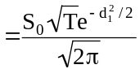 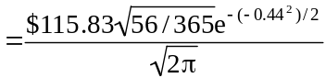 = $16.43

This suggests that a change in volatility of 0.03 would result in a call price change of
$16.43(0.03) = $0.4929.

22. (Time to Expiration) The rate of time value decay can be measured by the option’s theta. Call theta is given by:

Call theta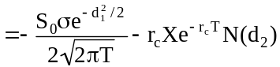

We are given: N(d₂) = 0.6368 (remember that N(d₂) is the probability of the option expiring in the money, therefore d₂ = 0.35 based on the Standard Normal Table given in the chapter), S₀ = $132.43, σ = 0.76,
T = 21/365, r_{c} = 0.0398, and X = $130. We can use the identity d₂ = d₁ – σ(T^{1/2}) to find d₁ = 0.3682. Thus the call theta can be found using the above formula:

Call theta 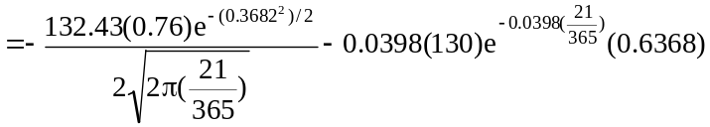 = 86.2813

Thus, in three days, the option price would be predicted to change by ((21/365) – (18/365))(86.2813) = $0.7092.

23. (Put Option Pricing Models) We are given X = $120, S₀ = $126.30, r_{c} = 0.0348, and T = 28/365 = 0.0767. The Black-Scholes-Merton model for European puts (obtained by applying put-call parity to the Black-Scholes-Merton model for European calls) can be represented as:

P = 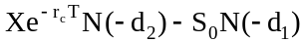

In order to use the above model we must find N(-d₁) and N(-d₂). This can be done using the identity:

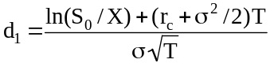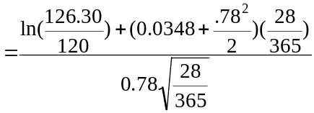

Thus,

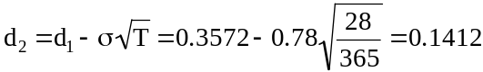

Therefore, N(–d₁) = 0.3594 and N(–d₂) = 0.4443. We can now solve for the option price using the Black-Scholes-Merton model for European calls:

P =

24. (Stock Price) The value of h shares of stock and one put is

V = hS + P.

The change in the value of the portfolio is

ΔV = hΔS + ΔP.

Divide by ΔS and set to zero to establish a hedge:

ΔV/ΔS = h(ΔS/ΔS) + (ΔP/ΔS) = 0.

Solve for h:

h = –ΔP/ΔS.

This is the put delta. From the chapter we know that the put delta equals N(d₁) – 1. So

h = –(N(d₁) – 1) = 1 – N(d₁).

Since N(d₁) is less than 1, then h > 0. That means we will buy stock. This should make sense. If we are long puts, we need to buy stock to hedge because the put will lose money when the stock price rises.

25. (A Nobel Formula) a. Inserting the numbers into BlackScholesMertonBinomial10e.xlsm gives a call
value of 6.0544.

- The call is underpriced so buy it, thereby investing $500.

- The call price is calculated below using a time to expiration of T = 2/12 = 0.167, the stock price shown on the same line, and the same other inputs.

Stock price Call price Profit
60 0.0942 100(0.0942 – 5) = –490.58
70 1.1151 100(1.1151 – 5) = –388.49
80 4.8772 100(4.8772 – 5) = –12.28
90 11.9136 100(11.9136 – 5) = 691.36
100 20.9455 100(20.9455 – 5) = 1594.55

